2026 Men’s League Rules & Regulations
Format: Singles Matchplay: Each player will play a nine-point match against their corresponding opponent. Every hole is worth one point with ties on a hole resulting in half a point for each player. Players can concede a hole or putt to an opponent if they wish. For scoring and handicapping purposes, the most likely score should be written in. An example of this would be a player lying three, twenty-feet from the hole being conceded the hole. A five should be scored because the likelihood of two putting would be most probable
In the event of a no-show the absent players' team will be awarded zero points for that match while the opposing team will receive at least 4.5 points for showing up. The person whose opponent did not show will still play but will play against their handicap instead of a person, with the possibility of gaining more than 4.5 points
Team Roster: All players must have a certified up to date GHIN handicap. Any players without a valid handicap will play to a zero, until a handicap can be established. Players are limited to be listed on the roster of a single team only. Teams will be allowed to have a maximum of two (2) substitute golfers on any given night of regular season play. Roster changes are allowed up until August 1st at which time no changes will be allowed for the remainder of the season. I
Handicapping: All players will use their corresponding course handicap for their matches. Indexes are not used, only course handicap. If you play the silver tee, you will use your course handicap from the silver tee. If you play the maroon tee, you will use your maroon tee course handicap.
There are no half strokes in handicapping players. Last year there was some confusion that players could receive half a stroke if they had an odd numbered course handicap. An example of this would be a player with a course handicap of seven from the maroon tee taking 3.5 strokes for the nine-hole match. What should be done is to ignore your course handicap for 18 holes. Rather, please use the GHIN system either online on PC or the GHIN app available for your mobile phone. Navigate to the Handicap Calculator, choose Hamilton Golf Course, choose 9 holes (rather than 18), choose the tees you’re playing (Maroon, Combo or Silver), and whether you are playing the front nine or the back nine. The system will provide you with your Course Handicap for our nine hole matches. By way of example, an 8 handicap for 18 holes is actually a 5 handicap for 9 holes if playing the maroon tees on front nine. If that same player was playing the back 9 from the maroon tees, they would be a 3 handicap. The reason for the large deviation between nines is that the course has been rerated and the back 9 is significantly easier than the front nine.
- -
Scoring: All scorecards should be legible, clean and easy to read. I have attached below an example of how your card should look and be scored. Any unidentifiable scorecards will forfeit their teams' points. All scorecards should be turned in to the-golf shop counter immediately after play is finished.

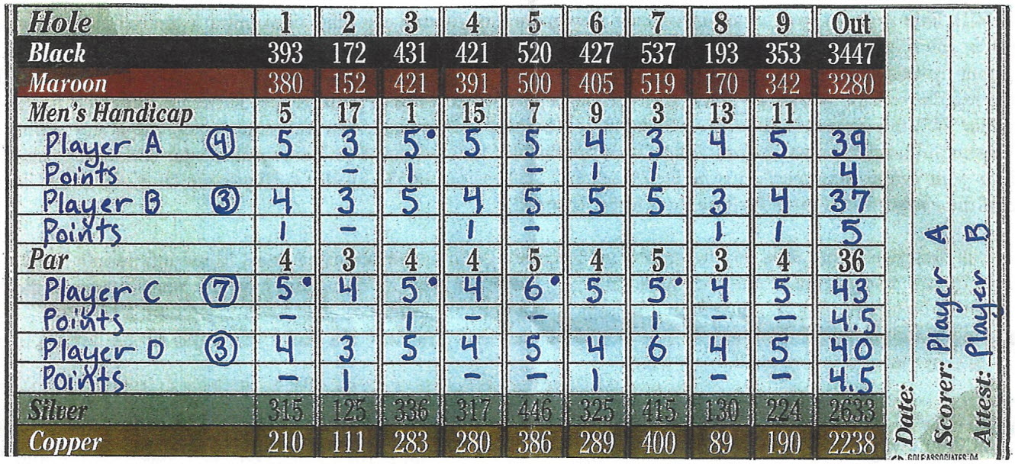 Team A/C should add their point totals and write them on the back of the scorecard next to their team name
Team B/D should add their point totals and write them on the back of the scorecard next to their team name
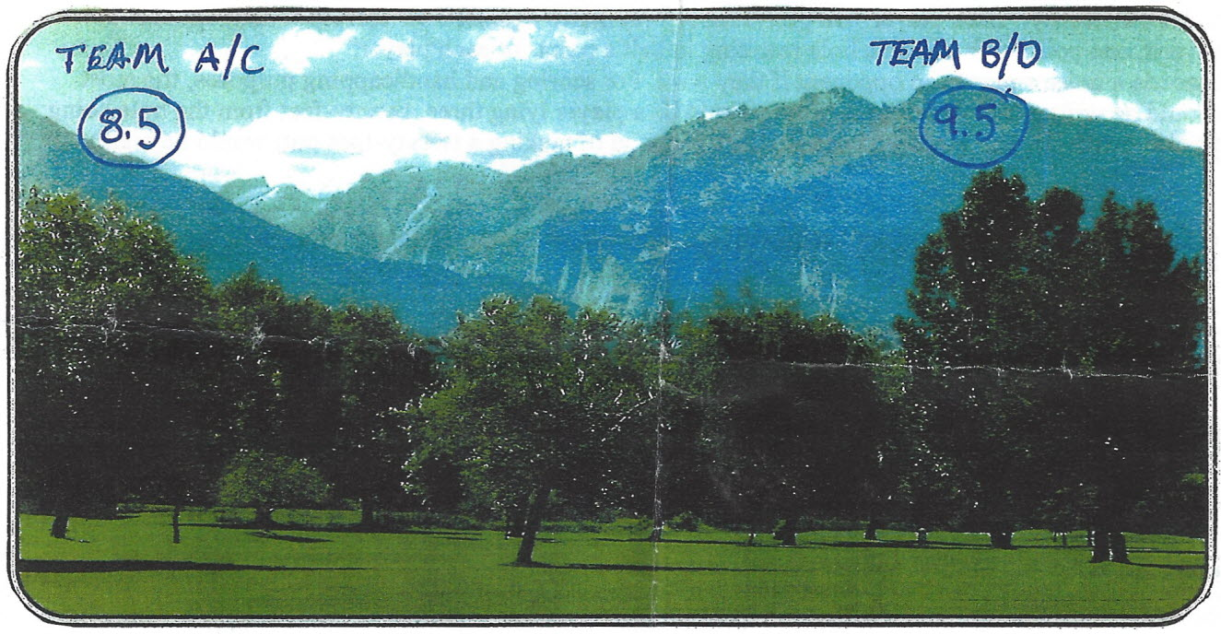
Playoffs: The size of this years men's league is bigger than any in recent memory. Because of this, the playoffs have been adjusted accordingly. In an effort to keep all teams interested and competing, the full length of the season, this year's playoffs will include the top twelve teams out of the nineteen teams we have. Of those twelve teams, the top four regular season finishers will receive a bye to the final eight. The eight teams remaining below the top four, will be paired up based on their finish and playoff, until four teams remain. From there, the final eight remaining teams will be re-seated and playoff.

Substitutes are allowed to compete in the playoffs, including players from another team’s roster but are limited to only 2 subs for the playoffs. All playoff participants must have played a minimum of three (3) times during the regular season.
As always there will be a weekly $5 dollar deuce pot that will be paid out in cash the following week.
Rules: We are playing under all USGA rules during the whole match. However, you may ask your opponent before the first ball is hit if they want to establish a root rule or not. If you both agree on having a root rule then that is how the match will be played, but if you cannot agree on having a root rule then it falls back to USGA and there is no free relief from the roots. Furthermore, there have been a lot of tree removals and stump grinding this past season and with that the maintenance crew has put out fresh mulch to help grow the grass. The mulch is a ground under repair area and is a free drop. Please do not hit your ball from the mulch so we let the grass grow. Also, all cage trees that affect your swing or stance (not ball flight) are considered free relief and you are intitled to a free drop. Any other ruling questions that you are unsure of, call the pro shop and they will tell you the official ruling.
Pace of Play: Your matches shouldn’t take any longer than two hours for nine holes. Play ready golf and plan accordingly to get your drinks from the beverage cart girl so play is not held up.
I plan on posting weekly men's league standings on the golf course website golfhamiltonmt.com. go to the events tab and click on the leagues link. This will bring you to the Men’s League description and a link to League Current Standings.

